THEORY QUESTIONS
1.
(a)

Simplify:
2
3
of 6
3
4
÷
(2
4
15
−1
2
3
)
.
(b)

Solve the equation
1
3
(x + 3) - 2(x - 5) = 4
1
3
.
(c)

If 3y = 2x² - 3x + 7, find y, when x = 5

2.
(a)

In the diagram, PADQ and RBCS are parallel lines. │BD│ = │DC│, angle ADB = 65° and angle ABR = 50°.
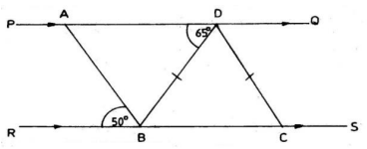
(i)

Calculate the angle BDC.
(ii)

Calculate angle ABD.
(iii)

Find angle BAD.
(iv)

What type of triangle is triangle ABD?
(b)

Using a ruler and a pair of compasses only, construct triangle XYZ, with |YZ| = 8 cm, angle XYZ = 60° and |XY|=9 cm.
Measure
(i)

angle YZX;
(ii)

|XZ|

3.
Ama was granted a loan of ₵800,000.00 by a bank. The rate of interest was 42% per annum.
(a)

Calculate
(i)

the interest at the end of the year;
(ii)

the total amount Ama had to pay at the end of the year.
(b)

Ama was able to pay only ₵700,000.00 at the end of the year.
(i)

Find how much Ama still owed the bank.
(ii)

Express the amount Ama owed after paying the ₵700,000.00 to the bank as a percentage of the loan she took from the bank.

4.
The following is a record of scores obtained by 30 JSS form 2 pupils in a test marked out of 5.
5, | 3, | 2, | 4, | 5, | 2, | 4, | 3, | 1, | 1
3, | 4, | 2, | 3, | 4, | 5, | 3, | 4, | 3, | 2
4, | 3, | 1, | 2, | 2, | 3, | 3, | 2, | 4, | 3

Score (x) | Tally | Frequency (f) | fx
(a)

Copy and complete the table.
(b)

Find the mean of the distribution.
(c)

If a pupil is selected at random from the form, what is the probability that he/she scored 4 marks?

5.
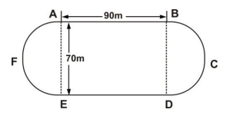
The diagram shows a running track ABCDEFA. AB and ED are the straight sides. The ends AFE and BCD are semi circular shapes.
|AB| = |ED| = 90 m and |AE| = |BD| = 70 m.
Find
(a)

the total length of the two semi circular ends, AFE and BCD;
(b)

the perimeter of the running track ABCDEFA;
(c)

the total area of the running track ABCDEF.
[Take π =
22
7
]

